<https://www.twobitarcade.net/article/displaying-images-oled-displays/>  
<https://blog.boochow.com/article/453875276.html>

<https://github.com/micropython/micropython/blob/master/drivers/display/ssd1306.py>

Block diagram:

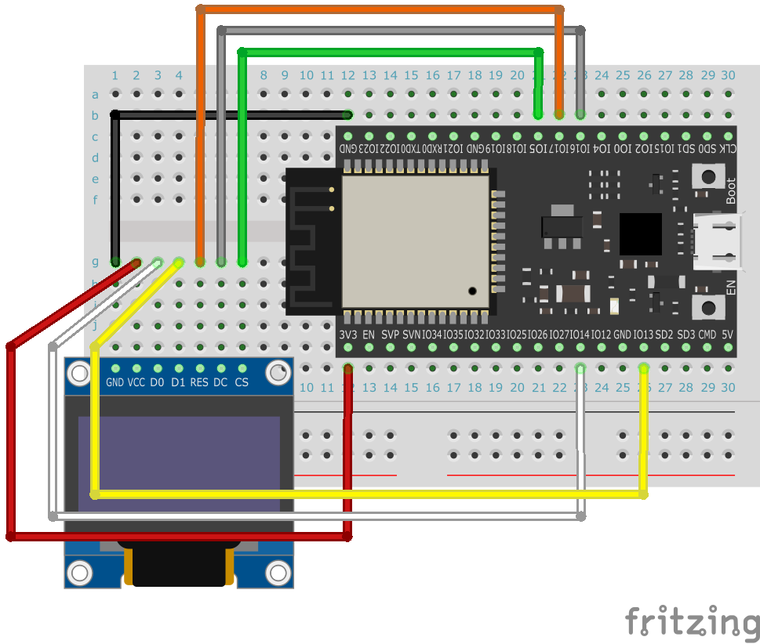

Pin:

OLED ESP32

GND GND

VCC 3V3

SCL IO14

SDA IO13

RES IO17

DC IO16

CS IO5

Then we need to import the micro python driver ssd1306.py And navigate upyloader.  
<https://github.com/micropython/micropython/blob/master/drivers/display/ssd1306.py>

from machine import SPI

from machine import Pin

from ssd1306 import SSD1306_SPI

spi = SPI(1, baudrate=8000000, polarity=0, phase=0, sck=Pin(14), mosi=Pin(13), miso=Pin(12))

oled = SSD1306_SPI(128, 64, spi, dc=Pin(16), res=Pin(17), cs=Pin(18))

oled.fill(0)

oled.text('Micropython', 0, 0)

oled.text('works fine!', 0, 10)

oled.show()  
  
  
  
Displaying image:  
  
<https://www.twobitarcade.net/article/displaying-images-oled-displays/>

import framebuf

from framebuf import FrameBuffer

with open('scatman.pbm', 'rb') as f:

f.readline() # Magic number

f.readline() # Creator comment

f.readline() # Dimensions

data = bytearray(f.read())

fbuf = framebuf.FrameBuffer(data, 128, 64, framebuf.MONO_HLSB)

Then for loading image:  
  
oled.invert(1)

oled.blit(fbuf, 0, 0)

oled.show()